Day 10 (20 June 2025)
112552596 - vsisukhw - Sukhwinder Singh

Task 1
What is a Process ?
A process is a program that is currently running on our computer.
- When we open Chrome, a process starts to run Chrome.
- When we play a game, the game becomes a process.
- Every app or program we open becomes its own process.

Task 2
What is a Thread ?
A thread is a small part of a process that does a specific task.
- A process is like a big task — for example, opening an app.
- A thread is a small worker inside that app that does one job — like loading images, playing music, or responding to clicks.

Task 3
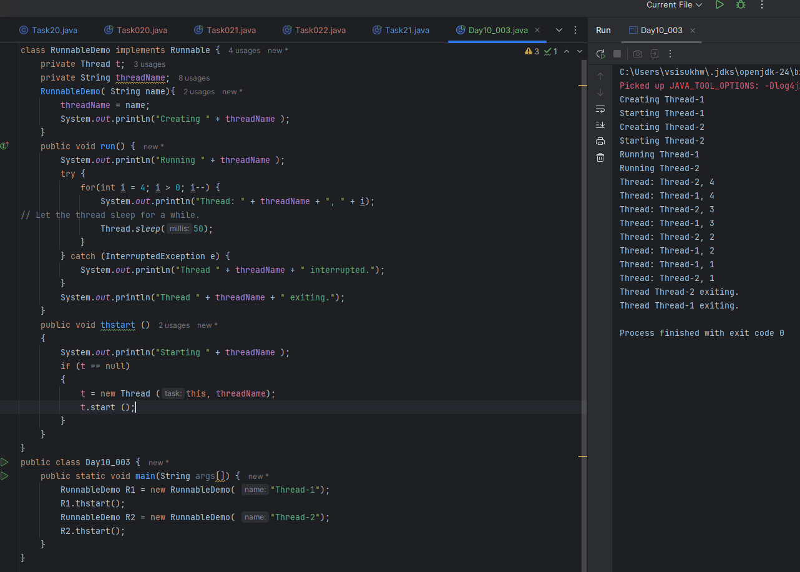

Task 4
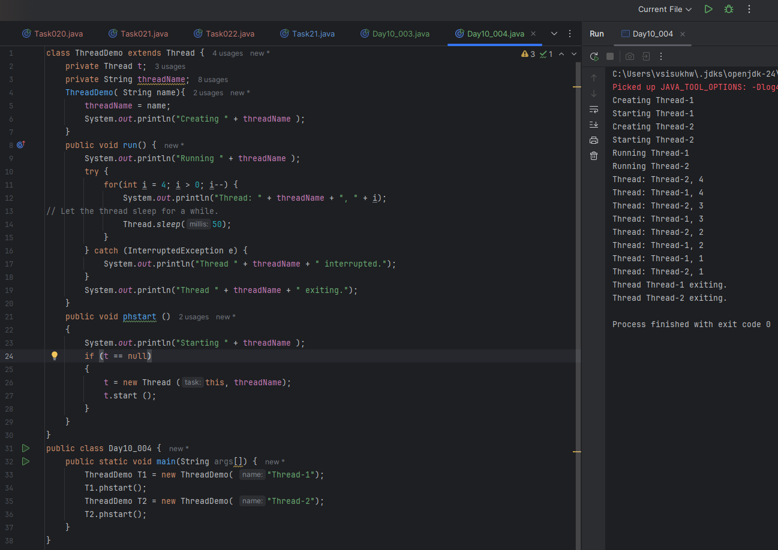

Task 5
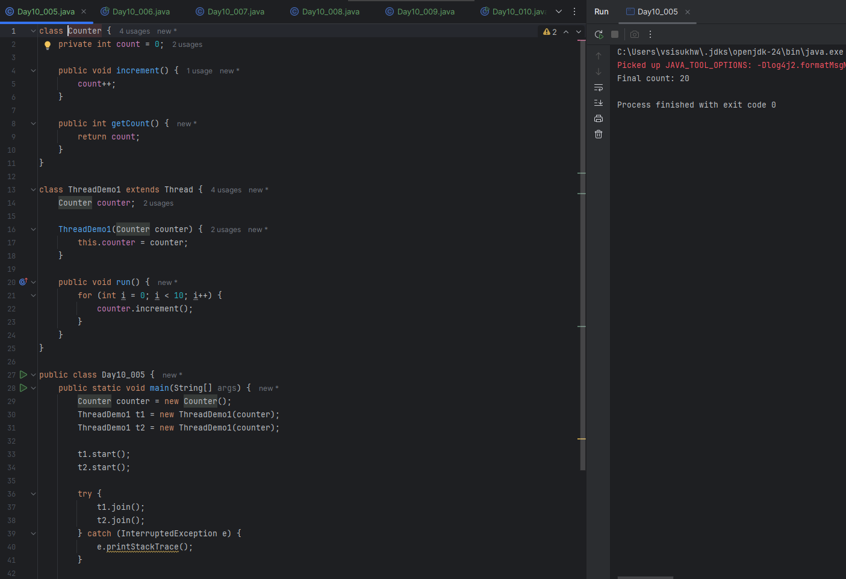
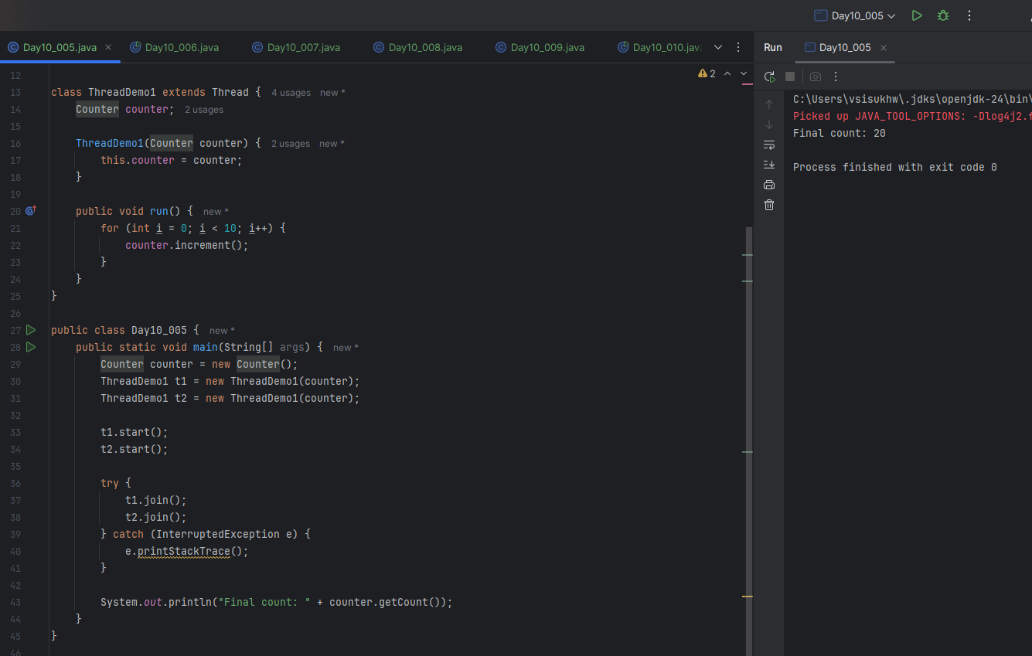

Task 6
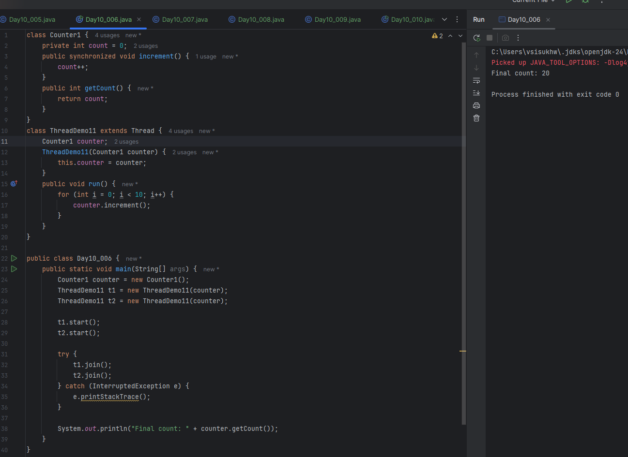

Task 7
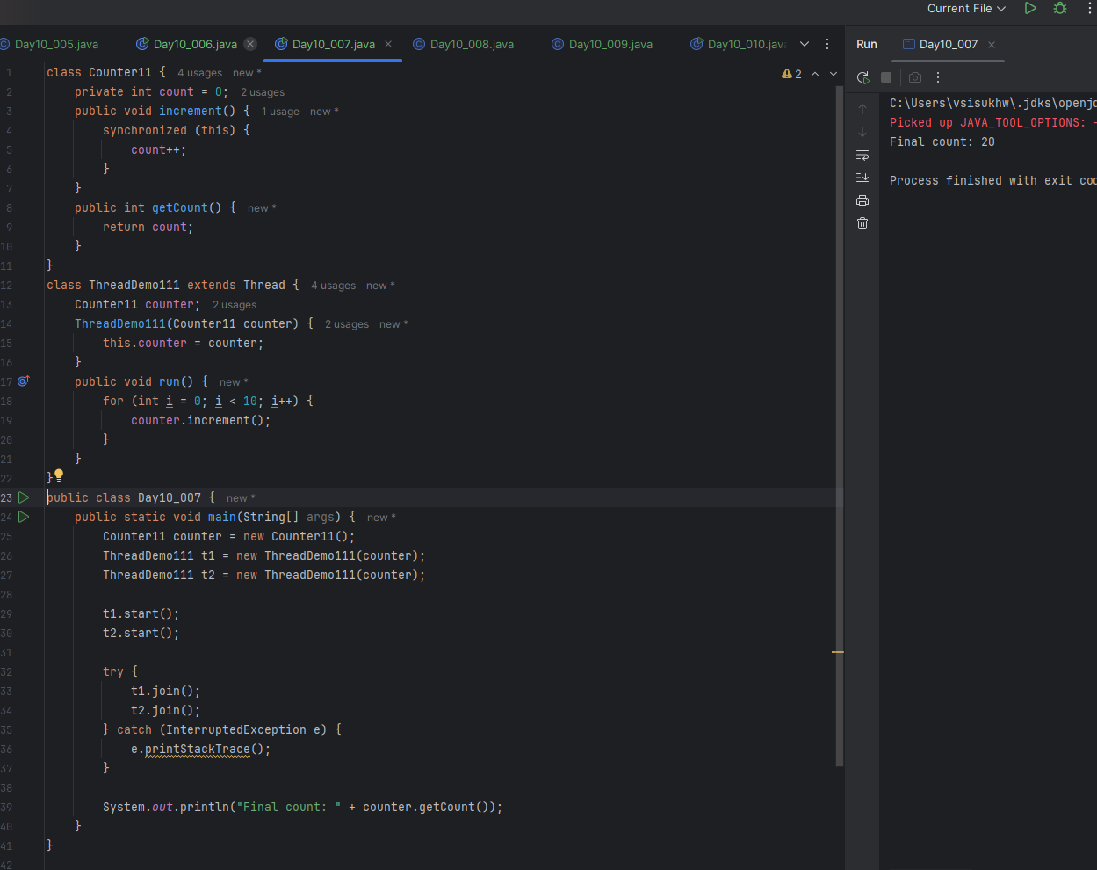

Task 8
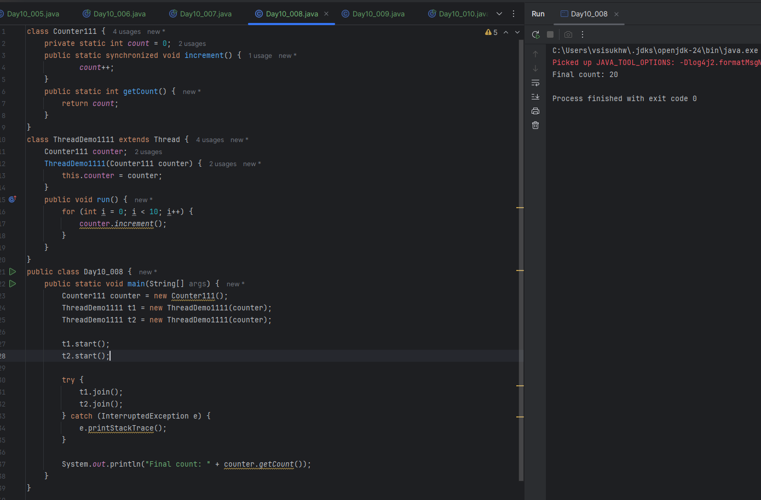

Task 9
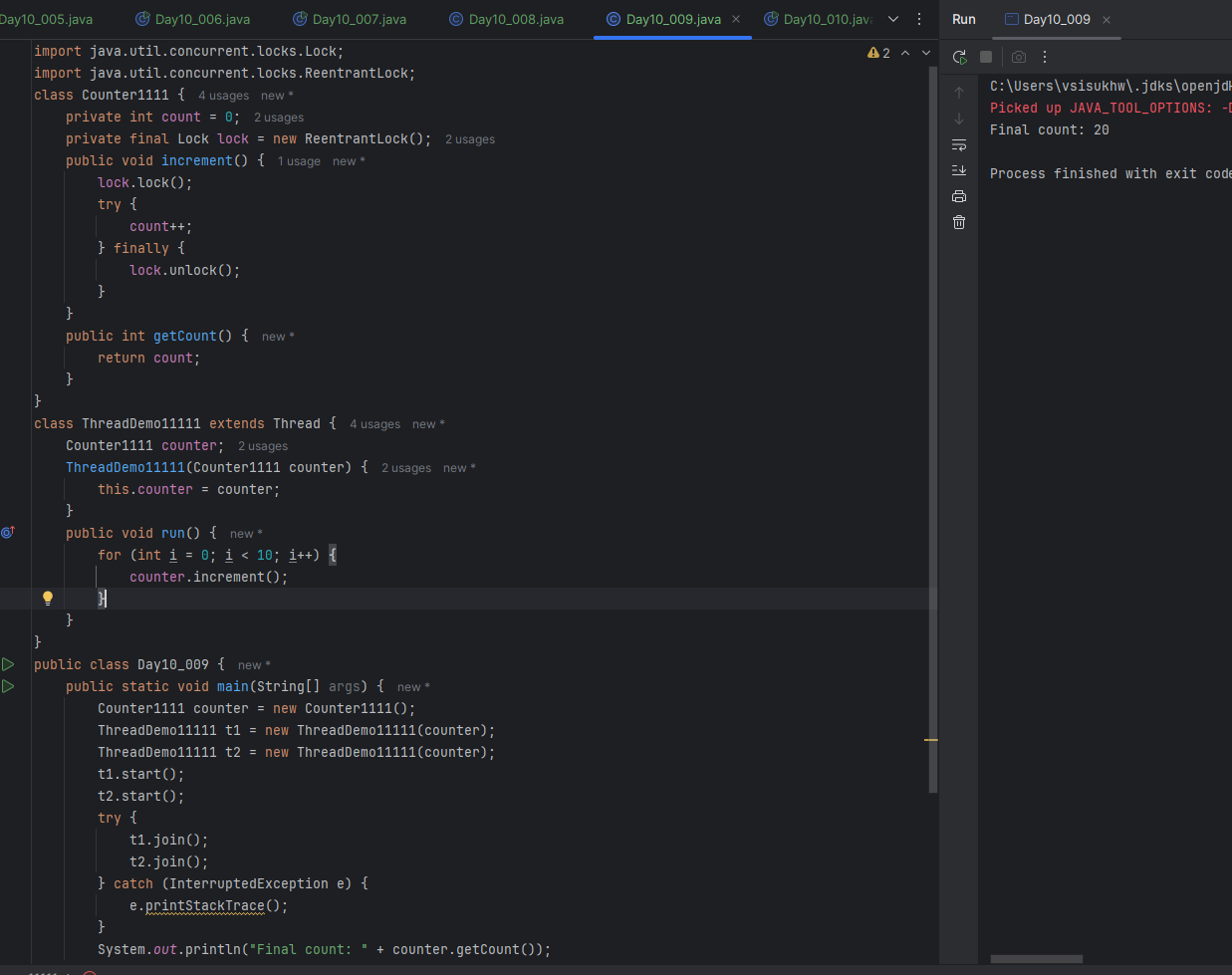

Task 10

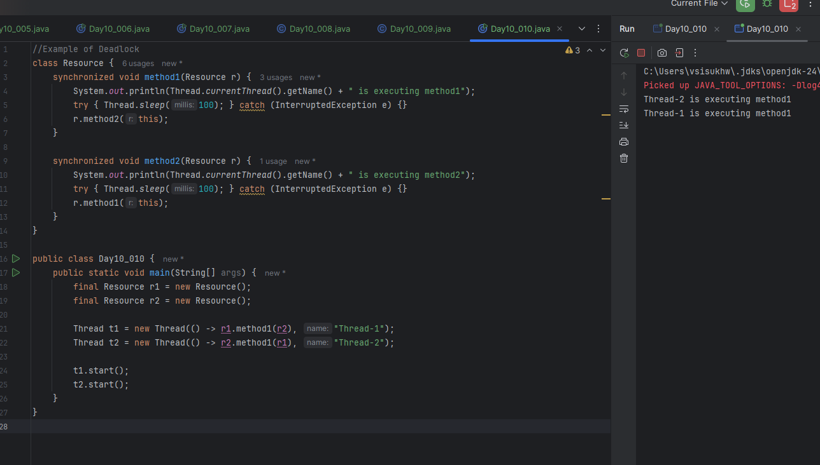

Task 11
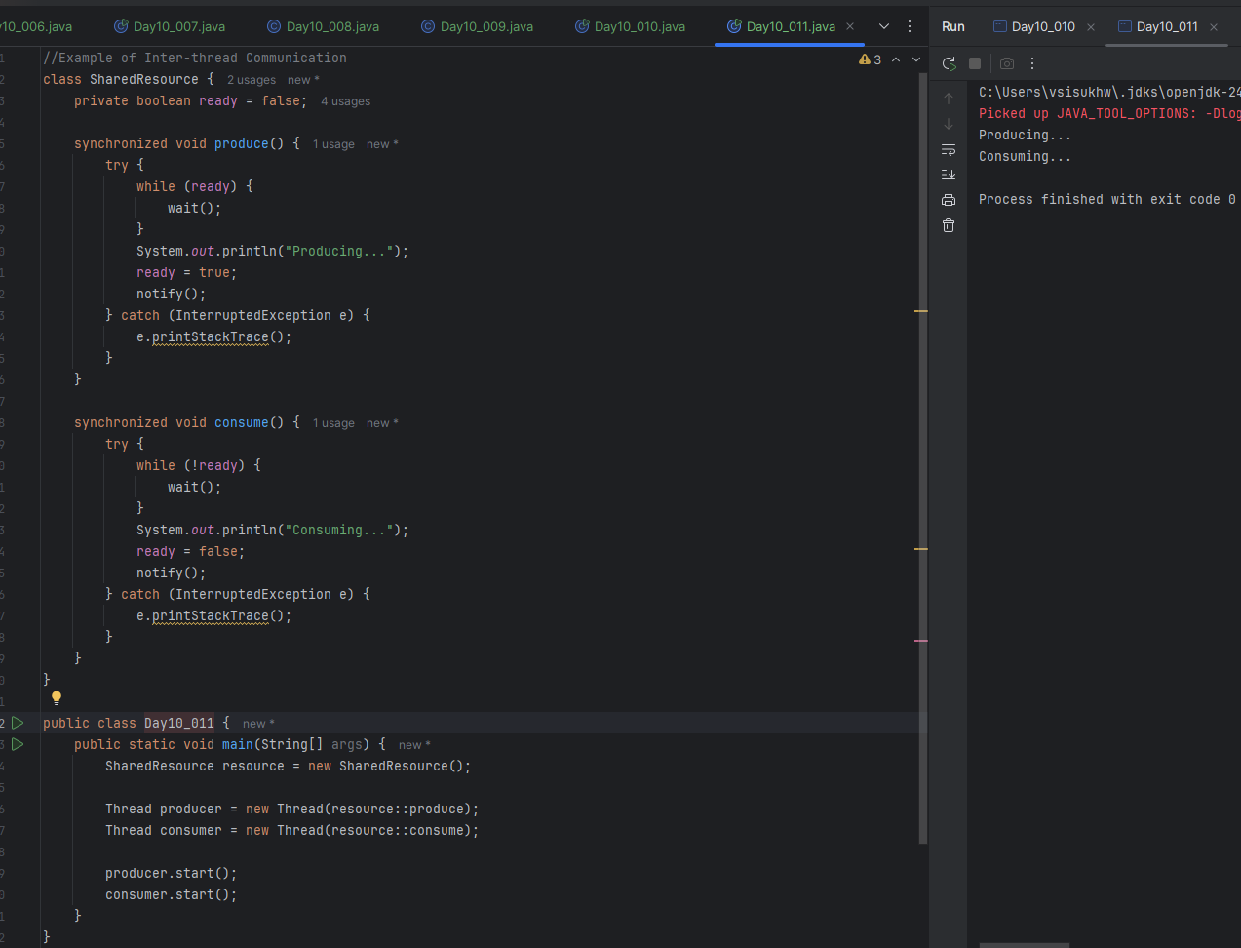
Task 12
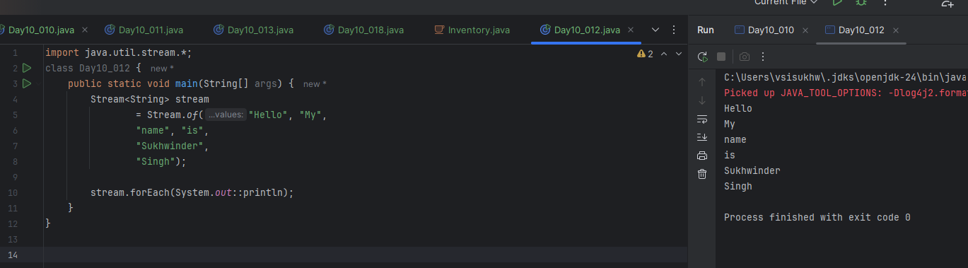
Task 13
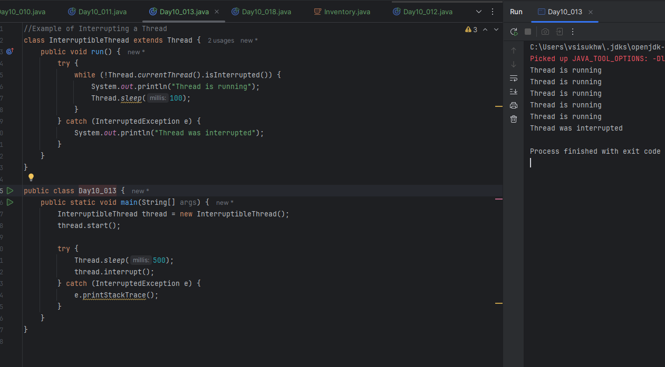

Task 14
What are Daemon threads? Explain…
Daemon threads are special types of threads in Java that run in the background and support the main (user) threads.
- It runs in the background (like a helper).
- It automatically stops when the main work (user threads) is done.
- Used for things like cleaning up memory, logging, etc.
- We must set it as a daemon before starting it.

Task 15

Java Debugging Tools:
- Eclipse Debugger
  - Built-in tool in Eclipse IDE.
  - Supports breakpoints, step-through, variable inspection.
- IntelliJ IDEA Debugger
  - Powerful and easy to use.
  - Supports conditional breakpoints, watches, memory view.
- NetBeans Debugger
  - Another IDE with built-in debugging tools.
  - Good visual support for debugging.
- jdb (Java Debugger)
  - Command-line debugging tool.
  - Comes with JDK.
  - Used for low-level or remote debugging.
- VisualVM
  - For monitoring and debugging memory, CPU usage, threads.
  - Great for performance profiling.
- JConsole
  - GUI tool for monitoring Java applications.
  - Comes with JDK.
  - Useful for checking memory leaks, thread usage.
- Java Mission Control (JMC)
  - Advanced profiling and diagnostics tool.
  - Works with Java Flight Recorder (JFR).
- Loggers (like Log4j, SLF4J)
  - Not traditional debuggers, but very useful for tracing and debugging issues through logs.

Task 16

What are Error Messages in Java?
In Java, when something goes wrong in your code, Java gives you a message called an error message to help you understand what the problem is.
There are two main types:

1. Compile-Time Errors
These are errors that the compiler catches before the program runs.

Example:
- Missing ; or { }
- Wrong variable names
- Using undeclared variables

int x = 10 // Missing semicolon
System.out.println(x)

2. Run-Time Errors (Exceptions)
These happen while the program is running. The program will compile but crash when it runs.

Common Runtime Errors (Exceptions):
Error | When It Happens
NullPointerException | When you try to use an object that is null.
ArrayIndexOutOfBounds | When you access an array element with an invalid index.
StackOverflowError | When a method keeps calling itself and never stops (infinite recursion).
IOException | When input/output operations fail (like reading a missing file).
ArithmeticException | Dividing by zero.

Task 17
What is Stack Trace. What will it do?

A stack trace is a detailed report that Java provides when an error (usually an exception) occurs at runtime. It shows the path your program took, step-by-step, through method calls, leading up to the error.

What Does a Stack Trace Do?
It helps you trace the exact location of the error in your code:
- Which method was called?
- From which file and line number?
- In what order did the calls happen?
- What was the root exception?
Task 18
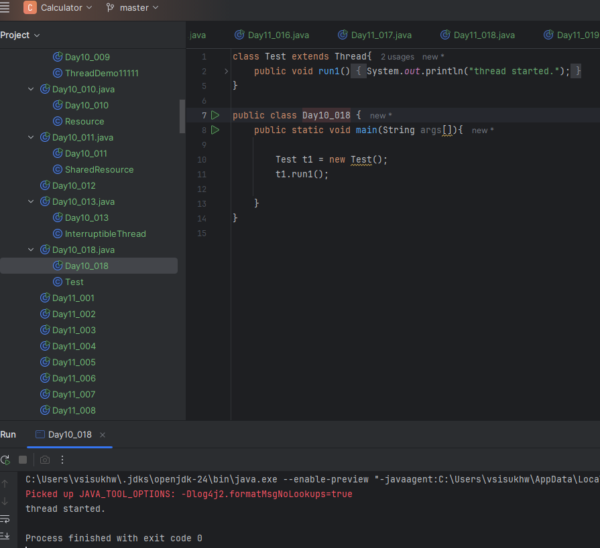
Task 19
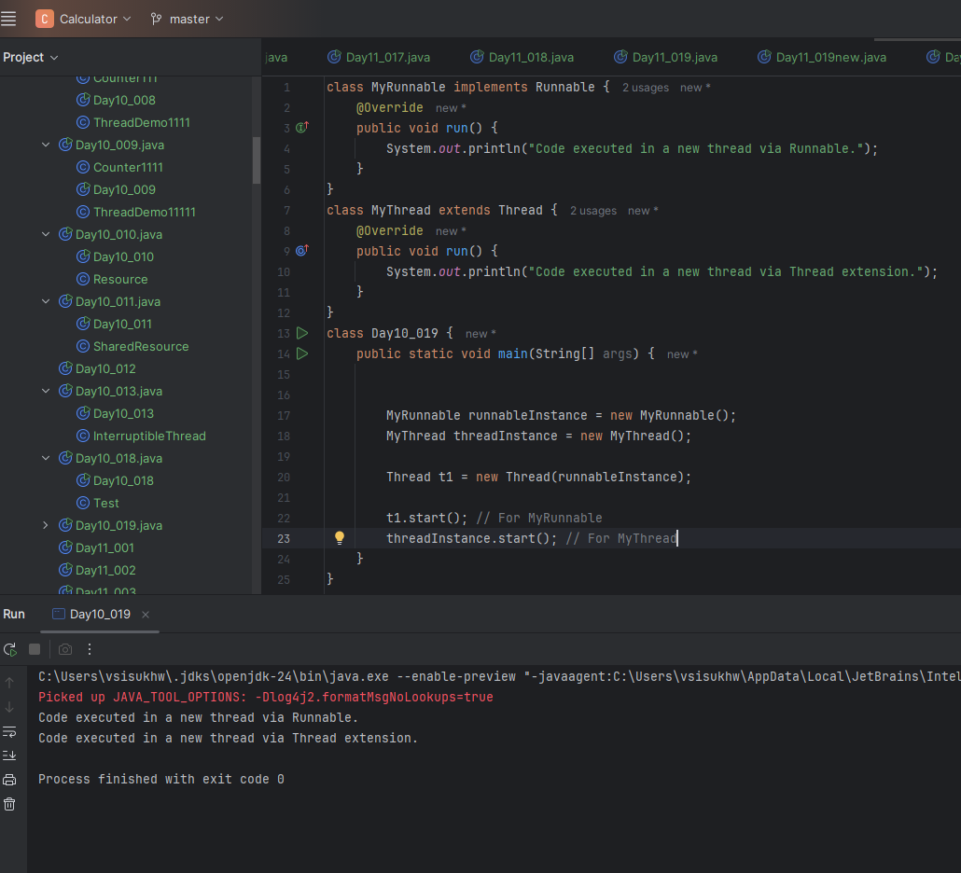

Task 20
